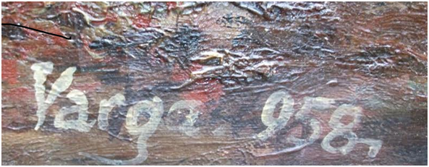

Signature photo's on CERTIFICADO.pdf after removal of white "Varga 958" signature:

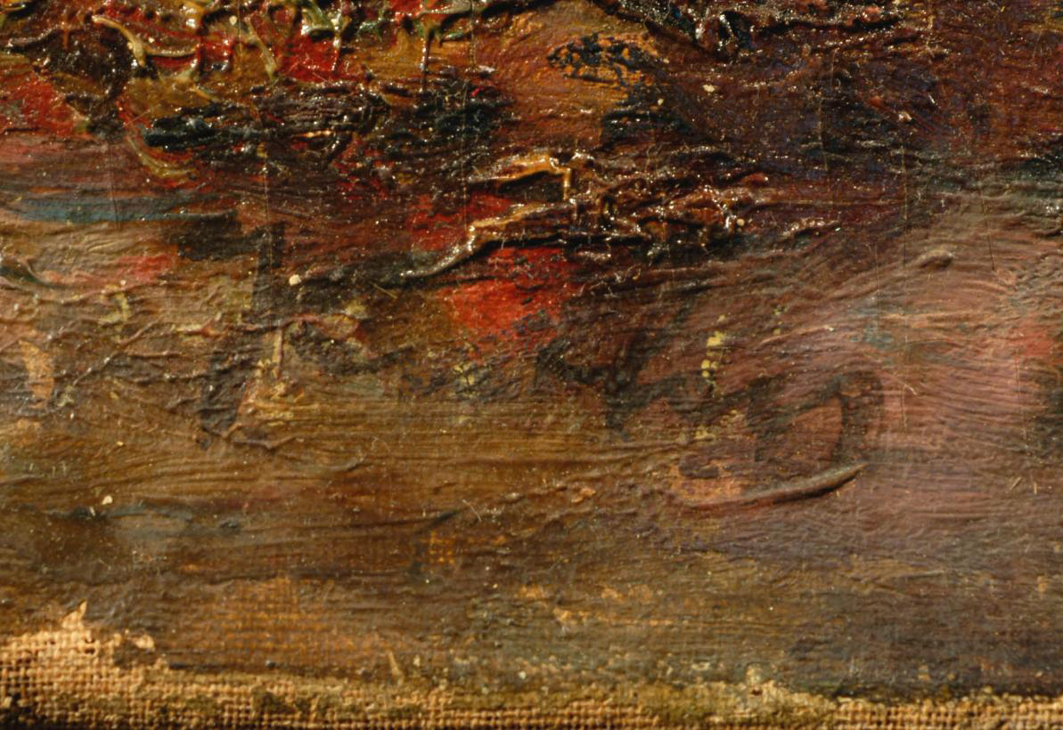

The examination of the signature using the scientific techniques, in particular the infrared reflectography and the subsequent digital processing, allowed us to improve the legibility. We have attached the photo of the signature under a normal light (photo no. 8) and the photo obtained after the digital processing (photo no. 9)

