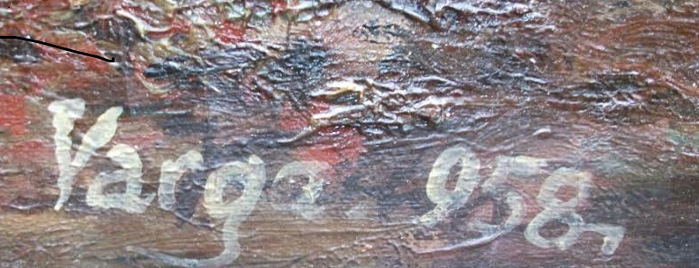

Original-Recipient: rfc822;hans831644@kpnmail.
Mon, 29 Apr 2019 20:25:47 -0700 (PDT)
From: Luisela Sanchez <idjsuarez@gmail.com>
Date: Mon, 29 Apr 2019 23:25:35 -0400
Subject: Unrevealed data
To: Leibbrandt Hans@leibbrandt.com

Dear Hans,

I hope you find yourself very well.
I write to you and annoyed you for a reason, that I wanted to tell you something, that I had not said about painting.
Motivated that there is no physical evidence of it.
The fact is that when we bought the painting, it had a signature on the signature.
This said: "Varga 58" finding out I spent a lot of time.
Until finally I learn that "Varga" is a typical surname of Hungary.
Finding out more that this could be the signature of Istvan Islovai Varga, who was something like the Head of the Hungarian artists' union.

This is located almost at the end of the Second World War.
Consulting with a Hungarian museum, they confirm that the signature coincides with that of Istvan Islovai Varga.
But the style, it was impossible that it was his.
Now my husband, checking at that moment, the painting, he observes, that under "Varga 58" there is another signature, which is currently seen.
He then proceeded to remove it carefully, but without consulting my son and me.
Destroying the evidence that was there!
The fact is that I only had one photo left, which I attached.
And thinking, what could have happened, I make the conjecture,
next: the one who placed the signature "Varga 58" did it to hide the signature of its true author.
If you enlarge the photo you can clearly see the two signatures.
Everything I have told you I do not know if it is important or not!
But I felt the need to tell you.
Waiting for your attention and your advice, expressing my most cordial greetings.

Louise

Content-Type: application/vnd.openxmlformats-officedocument.wordprocessingml.document;
name="VARGA 958.docx"
Content-Disposition: attachment; filename="VARGA 958.docx"
Content-ID: <16a6a40d721386287711>
X-Attachment-Id: 16a6a40d721386287711

VARGA 958.docx

