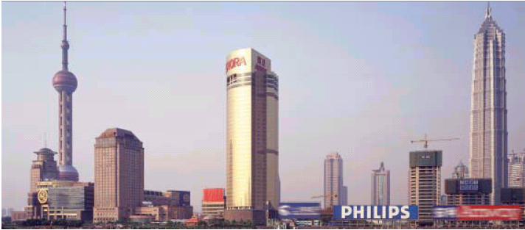

Partners in growth

Philips R&D in China enhances sustainable development and Open Innovation

Years ago, Mao Zedong rallied his
fellow communists with the cry,
“Serve the people!” Now, private
enterprises, led by Philips, are
serving the Chinese people in ways
Mao could not have imagined. Philips
Research plays a big role in the
company’s plans in the world’s most
populous country. Here’s how:

By Craig Brelsford

Healthcare
With healthcare unevenly distributed
throughout China, the need is great for mid and
low-end medical applications, especially
for the poorer areas in the hinterlands and
northeast. Philips Research has identified the
development of such applications as a
priority.
To that end, Philips is actively pursuing
healthcare partnerships in China. In June, the
company created a joint venture with the
Chinese company Neusoft to develop and
manufacture Computed Tomography (CT),
MR, and X-ray and Ultrasound equipment in
the northeastern city of Shenyang.

“We are here to be inspired
by the environment.”

“With China’s underserved rural areas
firmly in mind, Philips Research is also
developing telemedical applications,” said
Wouter Leibbrandt, head of the opticalstorage
and digital-television department at
Philips Research East Asia in Shanghai. “The
idea is that through the Internet and
mobile-phone technology, doctors in rural
areas can get access to remote service
centres,” he says. In a related activity Philips
is contributing to Chinese distance
education and training. A low-cost, easy to
use and easy to maintain open architecture
for distance learning, developed and funded
in collaboration with several Chinese
partners, is the latest result of this
commitment.
In serving such areas, the policies of the
Chinese government and of Philips are in
harmony. The Chinese government wants to
smooth out the country’s regional
imbalances, seeing them as a threat to
economic growth. Philips, meanwhile,
continues its century-old tradition of
improving people’s lives while taking part in
the broadening and deepening of the
Chinese market.

Telecommunications
With more than 300 million mobile phones
in China, the Chinese are the No. 1 mobile phone
users in the world. Small wonder,
then, that Philips bases so much of its
research into the technology in China.As
Leibbrandt says, “We are here to be inspired
by the environment.”
Cooperation on setting standards for
Chinese mobile-phone networks is a top
priority for Philips Research, says Yonggang
Du, department head at Philips Research
East Asia in Shanghai and a specialist in
telecommunications standards. “In 2003,
Philips set up a joint venture with Samsung
and Datang Mobile for delivering cellular
TD-SCDMA chipset and reference design,”
Du said. “Together, we’re working on new
features for the new Chinese 3G standard.”

Optical storage
With around 80 percent of such products
made in China, optical storage is another
area where China is a world leader. Here,
Philips benefits from its front-row research
seat in China, supplying sub-producers with
world-class optical-storage components.
Philips’ research team in Shanghai is
currently trying to improve robustness (the
ability of disc players to handle a variety of
discs).
As with telecommunications networks,
optical storage also poses the challenge of
standardization, Leibbrandt says. “We are
active, along with a large conglomerate of
other players, in setting the next standard
for video publishing. A lot of the driving
force behind that is coming from Shanghai.”
The activities of Philips Research in China
accord with the broad plans for Philips in
the world’s most populous country. Philips,
for example, is committed to a strategy of
Open Innovation, partnering with
universities and research institutes in an
effort to create new knowledge and
markets. This spirit made a delegation led by
Philips Research CEO Rick Harwig and
Eindhoven University of Technology President
Amandus Lundqvist travel to China recently
for visits to four top universities in an effort to
establish cooperative links. And it is this same
spirit that has led Philips to establish 20 joint
ventures so far in the country.

“We work on telemedical
applications for the rural areas.”

Philips is also showing its confidence in
intellectual-property-rights (IPR) protection in
China by sponsoring intellectual-property
academies at the Tsinghua, Renmin and Fudan
Universities. Under the arrangement,
professors from these universities will visit
universities in the Netherlands and other
countries, while Philips sends IPR experts to
give lectures at Tsinghua, Renmin and Fudan.
Through it all, the hope is that by serving the
Chinese market closely, with solutions geared
to the particularities of the giant, developing
nation, Philips can grow along with China.The
long-term commitment to China was never
intended to bear quick fruit, but to allow
Philips to set deep roots in the country.
Even so, the relationship is starting to blossom.
Not quite two decades after launching its first
joint venture in China, the Middle Kingdom is
now the fastest-growing market Philips serves
and its second-largest, with revenues of $7.5
billion in 2003. Philips operates 16 R&D
centres in China.

It has been said that in all of history, no
country has improved itself economically as
quickly as China has done in the last 20 years,
a two-decade span that has seen 400 million
people escape severe poverty. Philips and its
Research team have both shaped and been
shaped by this positive upheaval.

Philips’ involvement in China stretches
back eight decades.A look at some of the
highlights:

1920s
Philips opens first offices in
China

1985
Philips sets up first joint venture
in China

1996
Philips opens optical-storage
factory in China

2000
Philips establishes Philips
Research East Asia, R&D centre
for Philips in the Asia Pacific
Region

2002
Philips becomes largest foreign
multinational in China

2002
Philips opens LCD plant in
Shanghai

2002
Philips China awarded
‘Extraordinary Contribution
Award of 2002’ by China
Foreign Invested Enterprises
Association

2003
Philips total annual revenue in
China surpasses $7.5 billion

2003
Chinese Premier Wen Jiabao
meets with Philips President
and CEO Gerard Kleisterlee in
Beijing

2004
Philips opens Consumer
Business Innovation Center in
Shanghai, its third innovation
centre in Asia and its 16th
R&D centre in China. Philips
China now has about 900 R&D
Staff

2004
Philips agrees to provide
MIFARE contactless chip
technology for new e-ticketing
system at Great Wall of China

2004
Philips sponsors intellectualproperty-
rights education at
Tsinghua, Renmin and Fudan
Universities

2004
Philips has generated and
patented 200 inventions in
China.The total number of
patents in China increased from
1,100 in 1997 to 6,500 in 2003.

2004
Philips and Shanghai autorities
sign Letter of Intent to establish
Philips Innovation Campus in
Shanghai

2004
Premier Wen Jia Bao visits
Philips headquarters in
Amsterdam, the Netherlands,
and gets demonstration on
range of advanced technologies
that can contribute to China’s
sustainable development goals

2007
Philips’ annual revenue in China
expected to reach $12 billion,
making China the company’s
largest market

