3 Dutch Leibbrandt’s, July 2003

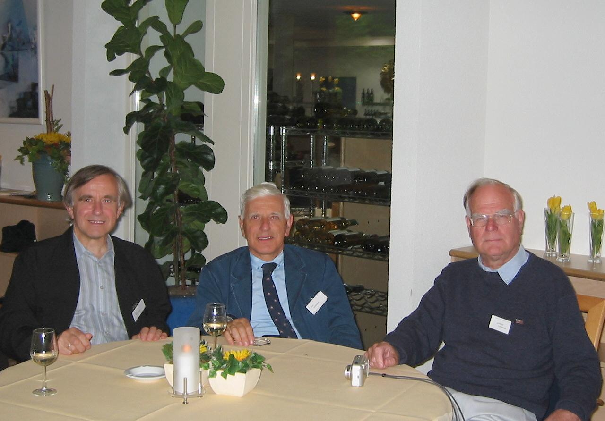

From right to left:

Dr Gottfried Johann Leibbrandt
Fomer Director-General for Higher Education and Research at the Dutch Ministry of Education and Research. Founding president of the Open University of the Netherlands
Dr Cornelis Christian Leibbrandt
Otorhinolaryngologist
1998 - 2002 Secretary-General of the UEMS (European Union of Medical Specialists)
Ir Hans Lodewijk Leibbrandt
El. Ingenieur http://www.leibbrandt.com/

