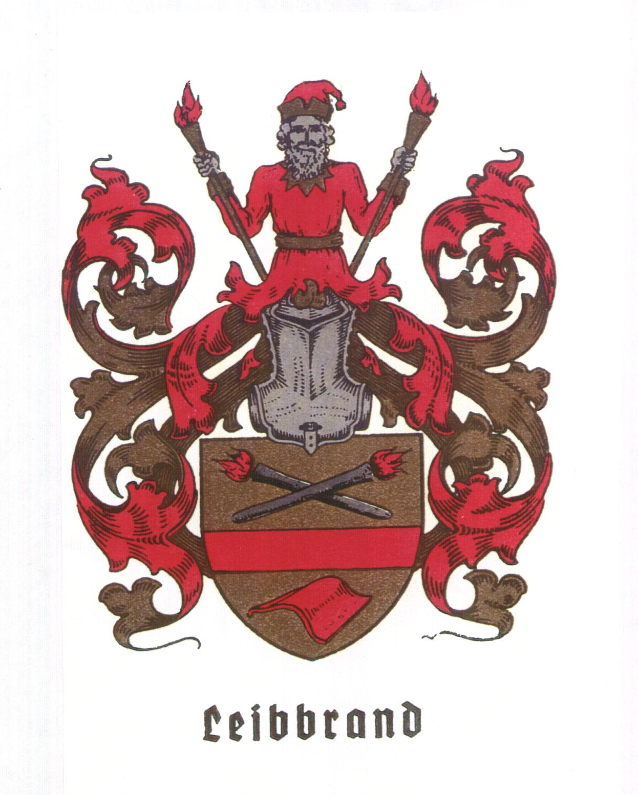
Hans Leibbrandt
Kievietlaan 4
5683 RC Best
The Neterlands
Phone/Fax: +31 (0)499 398260
E-mail: leibbran@iae.nl
http://www.iae.nl/users/leibbran

Best, 13 February 2002

To Ruth Leibrand in Forest City IA,

Looking for the combination of our family name and "genealogy on the Internet, I found you as President of the Lime Creek / Winnebago County Genealogical Society. No E-mail address was there.

Maybe you found already on:

http://www.iae.nl/users/leibbran/leibbsite

An extended web site with the big Leib(b)rand(t) family tree and other info about the genealogy and history of the family.
Also the many spelling variatons of our name are explained there.

"First occurrence of the family name: 8-th century
King Liutprand
Pronounced As: lootprand , died. 744, king of the Lombards (712-44). Under his rule the Lombard kingdom of Italy reached its zenith. The first Christian Lombard ruler, " etc.

The Leibbrandt family tree goes back to 1540 and contains 100 pages.
Branches 3x in USA, Canada, 3x in South Africa, 3x in the Netherlands, 3x Germany, Russia

You will receive a CD from me in the coming week.
The CD contains beside the web site also the "Leibbrandt_archive" with all the source material that was used.

I suppose that you will appreciate this information

Best regards,

Hans Leibbrandt in Best.

The Leibbrand coat of arms on this letter dates from about 1925 and was made in Stuttgart, Württemberg.
Germany.
It was sent to me by Walter Leibbrand in Kernen-Stetten, Württemberg.

