UNCERTAIN MINT

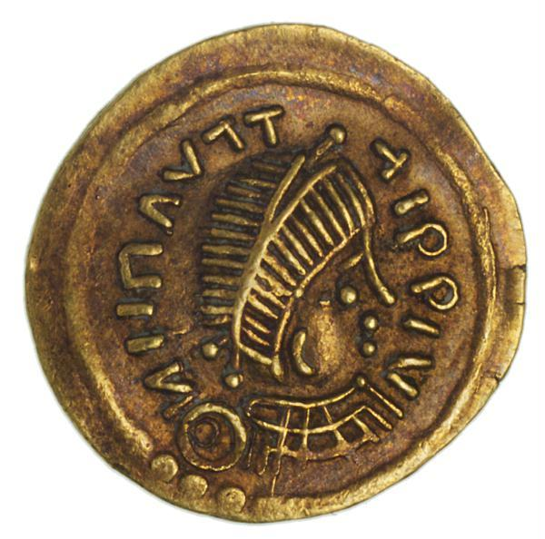 | Kingdom of Lombards, Pavia, Unknown Ruler, Tremissis, Gold, c. 650 AD  The Migration Period brought a renunciation from lifelike portraits. The Germanic princes and kings who had brought on the fall of the Roman Empire wanted their political position represented rather than their individual features. The portrait of a former Roman emperor on this coin struck in the upper Italian town of Pavia around 650 AD, was reduced to a few simple abstract lines that give it an almost modern touch.

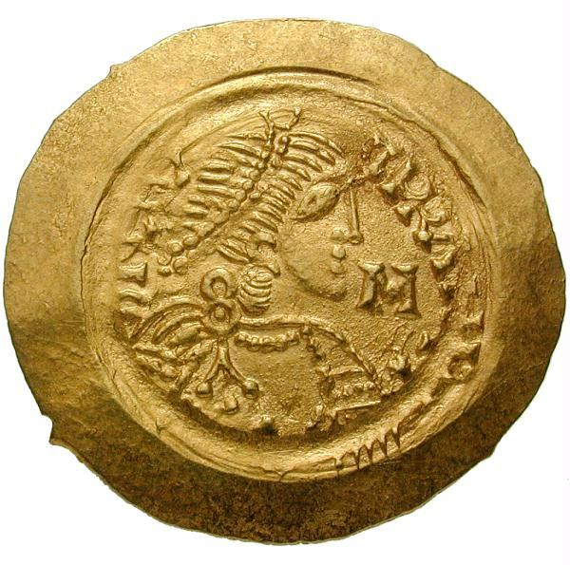 | Kingdom of Lombards, Uncertain Mint, Liutprand (712-744), Tremissis, Gold  The Germanic King Liutprand, who ruled over the kingdom of Lombardy as from 712, did not hold much with lifelike portraiture either. He felt it far more important to have his catholic belief recorded on the coin's reverse with the representation of Archangel Michael. Yet the imperial image on the obverse was so fine and sensitive that it still moves today's beholder.

Hoe moeilijk toch om steeds weer zeer secuur te werk te gaan; nu is L ook nog een GERMANIC king.

LINK:

- Money Museum
The Apollo head has a thoughtful air; the image comes close to a portrait. ... The Germanic King Liutprand, who ruled over the kingdom of Lombardy as from ...
finder2.moneymuseum.com/frontend/library/pictures/tour.jsp?lang=en&id=63519&ix=0 - 33k –

Obverse:
The side of a coin or medal that bears the principal stamp or design and, on U.S. coins the date.

En hierdoor moeten wij denkelijk wel erkennen dat er waarschijnlijk GEEN “images”, tekeningen of zelfs haard tegeltjes (grapje) van King L aanwezig zijn.

