The First Crusade

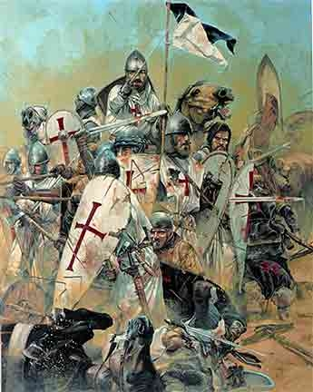

The First Crusades began in Western Europe in the year 1095 when Pope Urban II urged knights and peasants to expel the Muslims and Jews from the sacred city of Jerusalem, and also get rid of them from the Holy Land. The Pope told all who would fight would go straight to heaven. Many Christians joined the Pope's call to war. They became known as the Crusaders and wore a red cross to symbolize their unity in battle.

The Crusaders were led by four noble men and their army totaled about 30,000 men. In July of the year 1099, the Crusaders surrounded Jerusalem and they fought a tough battle, but in the end, the Muslims and Jews surrendered the city. All remaining Muslims and Jews were executed after they had surrendered the city to the Crusaders.

Works Cited:

(1) Wikipedia. First Crusade. August 30, 2007.

http://en.wikipedia.org/wiki/First_crusade

