Heraldry, coats of arms and family crests
by Mike Oettle
“DO you have a family crest?” is a question often asked out of snobbish pride (or envy).
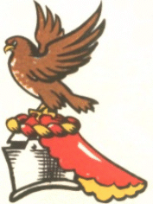
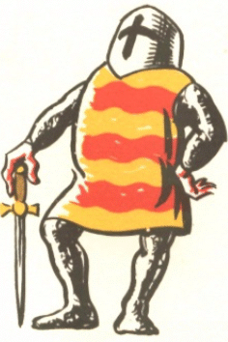
It’s an erroneous question, however, which arises from the abbreviated treatment given to some less prominent branches of families listed in works such as Debrett’s and Burke’s guides to the titled and landed gentry of Britain.
The crest – or helmet device – is only part of a coat of arms, or heraldic achievement, and it is not essential to have one as part of such an achievement. The essential part is the shield, the charges on it and the colours in which they are represented. The device on the shield was also repeated on the knight’s surcoat – giving rise to the term coat of arms – as well as on his horsecloths and his banner. (For more detail on how the basic elements of a coat of arms hang together, see this page.)
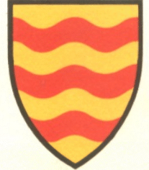
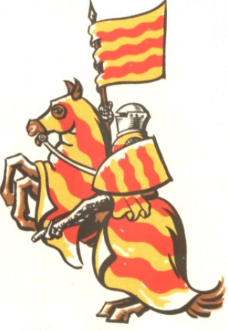
Heraldic devices – that is, emblems of a particular colour and shape used for military and personal identification which were passed on from father to son and were unique to the individual within each realm – can be traced back to a group of families in Flanders and adjacent lands, descendants of Charlemagne, who were using them in a recognisable form by the time of William of Normandy’s invasion of England.^{[1]}
Some members of these families formed part of William’s army, which although largely Norman also included Flemings, Bretons and other subjects of the King of France. Through the settlement of these “Normans” as great landowners throughout England, and in parts of Wales, Scotland and Ireland, and their emergence as a distinct class in what now became feudal England, the use of heraldic devices spread among the lords of Britain. Because these “Norman” families maintained links with their relatives on the Continent, heraldry also spread to other realms: at first to France and to Germany (the Holy Roman Empire), and later to Italy and Spain. By the period between the First and Second Crusades (the early 12th century), coats of arms were almost universally in use among knightly families in these countries and in the Kingdom of Jerusalem.
They were displayed in all kinds of ways, but notably in the seal device, which often depicted a knight in armour or became stylised from this representation, essentially showing a helmet with its crest and below it a shield, often hanging at an angle as it would from the arm of a knight riding, not actually fighting.
Having a coat of arms was a mark of belonging to the warrior class and being entitled to knighthood, even if one was so poor that one could barely afford sword, armour and horse, or if going to war as a knight meant drawing support from as many as seven other landholders (in England). In Germany, such poor knights were often counted as unfree. The knight was also an officer, expected (in England at least) to provide his own men-at-arms, and to equip and arm them too.
In later centuries, the countries of Europe adopted widely varying heraldic practices. In the Empire (which included the Netherlands, Belgium, Switzerland, Austria, Bohemia and the north-eastern parts of modern France, as well as, in its earlier stages, parts of northern Italy and even southern France) the aristocracy became highly exclusive, forbidding marriage between families of royal, princely and ducal rank and the middle aristocracy of margraves, counts and viscounts, or between these and the lower aristocracy of barons and knights. German counts also showed a tendency to arrogate themselves to higher rank, frequently converting their counties into principalities (Fürstentüme) or duchies.
(For more detail on how the German nobility is structured, click here.)
Bearing arms became tied to the rarefied and bloody art form of the tournament, where knights wishing to take part in this warrior sport had to display their armour, shields and helmets before the games began, and anyone considered unworthy (either because of lack of breeding or through moral turpitude) was expelled. Crests especially became ornate in the extreme.
http://uk.geocities.com/barensteel/crest.html

