Charlemagne
In the previous chapter, we saw how the iconoclastic controversy helped to weaken the Byzantine hold on Italy. By the mid-eighth century, the only part of the peninsula the Empire still controlled was the Venetian lagoon, part of the heel and the toe, and the Bay of Naples. Rome and Ravenna also technically belonged to the Empire, but now the pope was the real ruler of those cities. We saw Liutprand, the Lombard king, enjoy considerable success in the resulting power vaccuum. The two kings after Liutprand, Hildeprand the Useless (744) and Ratchis (744-749), though, weren't strong enough to follow up on Liutprand's victories, and both were removed by their dukes. Ratchis was succeeded by his brother Aistulf, who dreamed of conquering all of Italy; in 751 he seized Ravenna and was standing at the gates of Rome.
The pope may not have cared much for being the Byzantine emperor's puppet, but he didn't want a Lombard king for his overlord, either. For more than a decade he feared that he would become the Lombards' next target; in 739 he called on the Franks to save him from Liutprand, offering the title of patrician to Charles Martel. However, Charles wasn't interested, and the pope had to wait until Charles was succeeded by his sons Carloman and Pepin, before his pleas got a response.
At first, the two brothers followed tradition: Carloman became majordomo over the eastern half of the kingdom, while Pepin (also called Pepin the Short) took charge of the western half. In 743 they searched for a Merovingian to wear the king's crown, and chose a witless weakling named Childeric III. Then in 747, Carloman felt such a need to atone for his sins that he abdicated and became a monk. Now effectively ruling alone, Pepin showed that while he may have been less of a warrior than Charles, he was a better politician. Carloman's resignation, and Pepin's friendship with St. Boniface (they had cooperated in reforming the Frankish Church), suggested a solution to the kingship problem; if Pepin could get God's approval, it would be all right for him to replace the royal family with his own. In 750, with the encouragement of Boniface, he sent a letter to Pope Zacharias that asked a loaded question: should one man hold the title of king when another man holds the power?
This was an opportunity every pope had been waiting for since Gregory the Great. By giving Pepin the answer he wanted, Zacharias would put the most powerful man in the West in his debt, and get the help he needed to keep the Lombards away. Since Pepin had already proved himself a suitable ruler, in both his accomplishments and in his private life, the pope answered in his favor: "It is better that he who possesses power be called king than he who has none." Using this statement to justify his actions, Pepin convened a meeting of Frankish nobles and got himself "elected" king of the Franks.
Childeric III was shorn of his long blond hair (which made him unfit to be a king but fit to be a priest) and placed in a monastery, where he conveniently died within a year.
Pepin spent the rest of his reign repaying the pope for the favor. He told the Lombards to lay off Rome and when they failed to do so, crossed the Alps, brought them to heel, and gave the land they had taken back to the pope. Pepin also conquered Septimania, driving the Arabs back into Spain (759), and put down a major rebellion in Aquitaine (760-768). He died two months after that revolt ended, and the kingdom he bequeathed to his sons Charles and Carloman was both strong and primitive at the same time.⁽¹⁾
Charles has gone down in history as Charlemagne, meaning "Charles the Great" in Latin. This is because he was a determined and successful soldier, a talented statesman, and a patron of learning all rolled into one. There were 54 military campaigns during his 46-year reign, often on more than one front at the same time. When the Lombards made trouble by breaking treaties and seizing Papal lands, he finished off their kingdom, annexing all of north and central Italy (774). At the same time he added Byzantine Ravenna to Pope Adrian I's estates around Rome⁽²⁾, but kept most of the lands taken by the Lombards, even those Pepin had given to the pope previously. Charlemagne treated both Adrian and his successor Leo III with great kindness, but made sure they never forgot who was the boss.
Charlemagne had his greatest military successes on the eastern front, where he pushed the frontiers of the Frankish kingdom to the Elbe and upper Danube. Most of the time he declared he was advancing the cause of Christianity, though a few high-minded clerics deplored his method of conversion, which they called "baptism with the sword." In 784-5 he conquered the Frisians; by crushing the seafarers of the North Sea, he left a vacuum that the Vikings would soon fill. In 788 he took over Bavaria, which had shown an alarming tendency toward self-rule after it submitted to Frankish rule. In 796 he ended an old threat to the West by destroying the Avars in Hungary. To guard the East he set up a series of "marks" or "marches", special military districts in what is now east Germany, Austria and Slovenia. This established supremacy of a sort over all of the Slav tribes on the eastern frontier, from the Sorbs of the Oder River to the Croats on the Adriatic.
The still-pagan Saxons of northern Germany were his toughest opponents. It took 32 years of campaigning (772-804) to vanquish and pacify them. Since they were disunited, he had to conquer one tribe at a time, and between campaigns they launched savage raids into the Rhineland and France. On one occasion, he slaughtered 4,500 captives after they surrendered; on another, after one tribe's forced conversion, he chopped down the Irminsul, the great oak tree that they had worshiped previously, and out fell the tribe's golden treasury into Charlemagne's lap! The Saxons eventually accepted Christianity, though they never were very cooperative subjects.
The only direction in which Charlemagne did not win much ground was to the south; all he got for attacking the Moslems in Spain was the county of Barcelona and the Pyrenees mts. ("the Spanish March"). It did, however, give France protection from a possible Moslem revival.⁽³⁾

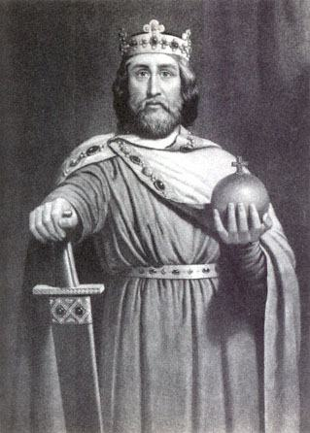
Charlemagne.
By the end of the century Charlemagne had brought nearly all of western Christendom under his rule.⁽⁴⁾ The Arabs sent him gifts worthy of a valiant foe; his favorite gift was an elephant named Abu-al-Abbas. The pope, however, presented the most impressive gift of all. It came about because, as the saying goes, "familiarity breeds contempt," and medieval popes had trouble getting along with the people of Rome. In 799 Pope Leo III was attacked by a gang of his enemies; he was beaten up, and they attempted unsuccessfully to cut out his tongue and gouge out his eyes. When he recovered from that ambush, he was charged with a number of crimes, including adultery, simony⁽⁵⁾ and perjury, and formally deposed. He could only get his name cleared and his job back by standing trial, so Leo fled to Germany, where he met Charlemagne, and Charlemagne went to Rome in December of 800, to testify on his behalf. Sure enough, the king's testimony won the pope's acquittal and reinstatement. Christmas came two days after the trial, and that's when Leo sprung his surprise. While Charlemagne was attending a mass in Rome, the pope placed a crown on Charlemagne's head, proclaiming Western Europe reunited as a "Holy Roman Empire," with Charlemagne as its first emperor. The congregation shouted, "To Charles, the most pious Augustus, crowned by God, the great and peace-giving emperor, life and victory!" Then Leo prostrated himself before Charlemagne, a gesture which popes had previously practiced only before the emperors of Byzantium. Though somewhat alarmed, Charles went along with the idea.⁽⁶⁾

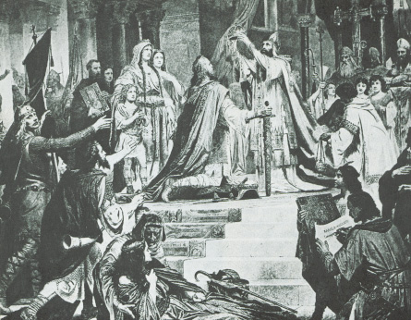
Charlemagne's Christmas present.
Theoretically only an emperor in Constantinople could bestow the imperial crown upon anybody else, but a legal loophole presented itself, in the form of Empress Irene. Although there was no law saying that a woman could not run the Empire, it had never been done before, so some--including the pope--felt that the throne was vacant so long as Irene had it. That gave the pope the legal justification to crown his own emperor. At the same time, the pope granted an even greater honor to himself; by crowning Charlemagne, he shrewdly made it look like the title of emperor was a gift from the Papacy. In the next chapter, we'll see what happened when popes got the idea that they could take away the title, as well as give it. Charlemagne had his own plan to reunite the East and West, by marrying Irene. According to the reports he heard, Irene was still beautiful, though in her late forties, and because of her unpopularity at home, she probably would have accepted the offer; it was the only way left for her to keep the throne in the East. The Byzantines would have none of it, though, and when they overthrew Irene, they also ended Charlemagne's chance to do things his way.
Actually the whole thing was nonsense. For one thing, it must seem absurd to the modern reader that two non-Italians--a Greek woman and a German man--could be accepted so easily as "Roman emperors." After the coronation, Charlemagne still ruled like an old German chief, uniting men through ties of personal loyalty rather than by laws. A century of three strong leaders--Charles Martel, Pepin the Short and Charlemagne--had made the Frankish kingdom look more impressive than it really was. The only thing it had resembling a legislative body was the annual meeting of the army. This was called the "Field of March" under the Merovingians, but Pepin had moved it back two months and invited clergymen to attend, so now it was the "Field of May." The only administration was the network of bishops and archbishops; the bureaucratic apparatus that should have managed the empire for Charlemagne's weak successors was totally non-existent. Consequently, the empire worked best wherever its ruler happened to be. For example, Charlemagne was so busy on the distant frontiers that he never found time to finish subduing the Celts of Brittany, right in his own backyard.⁽⁷⁾
During Charlemagne's time, long-distance trade started to increase, despite that fact that Moslem navies now controlled the Mediterranean Sea. Indeed, it was because the Mediterranean was a Moslem sea that Charlemagne gave legal protection to Jewish merchants, since they could travel through both Christian and Moslem territories without being automatically viewed as agents for the other side. The yields from farming also increased, for reasons covered later in this chapter (use of the heavy plow, the water mill, and the three-field system). In fact, the empire prospered to the point that Charlemagne could live off his personal estates without imposing a general tax on his subjects; obligations to the crown were always paid with service rather than with money. By modern standards western Europe was still not very rich or productive, and plagues and famine would remain a problem for centuries to come. However, now there was peace at home, and the only wars to fight were "good Christian wars" against far-away enemies of the Church, so Europeans could believe that life was getting better at last, and that they owed a lot of it to their just and powerful king, Charlemagne.
Early on Charlemagne realized that he would need educated and responsible men to keep his government working. His efforts to find these men and to train the up-and-coming generation began a small-scale cultural flowering that we call the "Carolingian Renaissance." By this time education of any type had all but disappeared; only among the clergy of England and Ireland was there a decent literacy rate, and things like wars, barbarian raids, and neglect had caused many classical works, like portions of the writings of Livy and Virgil, to be lost forever.
In Guizot's History of Civilization in France there is a list of the names and works of twenty-three men who were either grouped around Charlemagne as his advisors, assigned by him as advisors to his sons Pepin and Louis, sent by him to all points of the empire as his commissioners, or put in charge of important negotiations in his name. Those he did not employ at a distance formed a learned and industrious society, a school of the palace. Since learned men were in such short supply, Charlemagne recruited many of them from abroad. For example, the Visigoth poet Theodulf came from Spain and served as the imaginative bishop of Orleans. A short German from the east named Eginhard was both minister of public works and the official court historian. But it was in England that Charlemagne found a scholar with the skills of organization and leadership needed to manage his cultural revival everywhere in the empire--Alcuin of York.
Alcuin started by setting up the empire's first school, right in Charlemagne's capital at Aix-la-Chapelle (modern Aachen, Germany). Here both the sons of noblemen and their mustachioed fathers gathered in seminarlike classes to learn what would become the basic medieval curriculum: arithmetic, geometry, astronomy, music, and Latin literature. To us it would have seemed like a meager amount of learning, but Europe had been intellectually starved for so long that this must have seemed like a feast for the students. When not on a campaign or tour of the realm, Charlemagne would also participate, which generated some lively discussions. He eventually learned to read, but claimed that his hands were too callused from use of the sword to write, so all he did with a pen was sign his initials.
The enthusiasm of the school spilled over into the rest of the court. Sometimes Aachen was called a "Second Rome," and once Alcuin flattered the emperor by telling him, "If your zeal were imitated, perchance one might see arise in France a new Athens, far more glorious than the ancient--the Athens of Christ." Students gave themselves classical or Biblical names; Alcuin became "Horace," Charlemagne became "King David," and Eginhard chose for himself the name Bezalel, after the craftsman who built the Tabernacle and the Ark of the Covenant for Moses. Times of socializing thus became an improbable spectacle where war-hardened nobles, pious clerics and notorious womanizers (the latter included Charlemagne⁽⁸⁾ himself) engaged in contests of self-improvement, testing each other with riddles, witty remarks and scraps of ancient pagan poetry.
Because the Carolingian scholars were imitators rather than innovators, we must thank them for rescuing many classical works that might otherwise have been lost. The actual work of copying the manuscripts was very tedious; a trained scribe usually took three to four months on a single manuscript, much of it spent on the elegant decorations known as "illuminating." Some monasteries kept twelve or more monks working full time just on the task of copying, and the effort meant that by the ninth century there were some priestly "libraries" boasting a collection of a few hundred volumes. What this means to us is that no Roman work that survived long enough to be copied by Charlemagne's scholars was ever lost again. It is because of these dedicated copyists that the entire writings of Julius Caesar, Tacitus, Juvenal, Martial, and many other classical authors are available to us today.
After so many years of war and toil, Charlemagne spent more time at home, finding rest in this work of peaceful civilization. He embellished the capital with a palace and a domed octagonal basilica, the latter magnificently adorned. He fetched from Italy clerics skilled in church music, which he recommended to the bishops of his empire. In the outskirts of Aix-la-Chapelle "he gave full scope," says Eginhard, "to his delight in riding and hunting. Baths of naturally tepid water gave him great pleasure. Being passionately fond of swimming, he invited not only his sons, but also his friends, the grandees of his court, and sometimes even the soldiers of his guard, to bathe with him, insomuch that there were often a hundred and more persons bathing at a time."
When age arrived, he continued his daily habits, but at the same time, was taken up with the thought of death, and prepared himself for it with stern severity. He drew up, modified, and completed his will several times over. Three years before his death he made out the distribution of his treasures, his money, his wardrobe, and all his furniture, in the presence of his friends and his officers; two thirds of it was divided into twenty-one portions, which were to be distributed among the twenty-one metropolitan churches of his empire. Those were put under seal immediately, while he kept for himself the third share to maintain his lifestyle. After his death, what was left of it would be subdivided into four portions, which would go to the metropolitan churches, his sons and daughters, the necessities of the poor, and to the servants of both sexes in the palace for their lifetime. As for the books which he had amassed, they would be sold at their proper value, with the proceeds thus raised going to help the poor.
He did not seem too sorry to leave this world. A terrible famine swept the empire in 809. He lost his second son, Pepin, whom he had made king of Italy, in 810. In 810 he marched against the Danes, who had refused to acknowledge his authority, but before he got to the frontier his trusty elephant Abu-al-Abbas died, and he called off the campaign. Another constant companion in wartime, his eldest son Charles, died in the following year. Finally he wore himself out haggling with the Byzantines; it took until 812 to make them recognize him as the Western Roman emperor, and accept the passing of this title to his last surviving son, Louis.
He died in January of 814, at the age of 70 or 71; his ponderous corpse was reportedly buried sitting upright on a throne, in his chapel at Aix-la-Chapelle.⁽⁹⁾
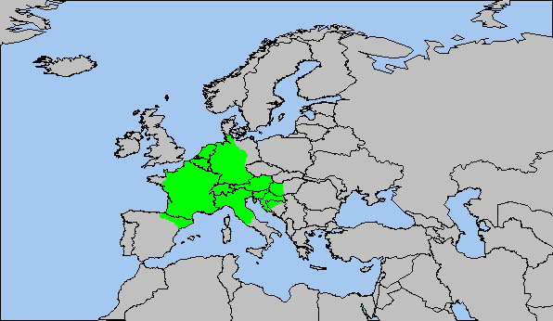
Charlemagne's empire, 814 A.D.

LINK:

xenohistorian.faithweb.com/europe/eu07.html

