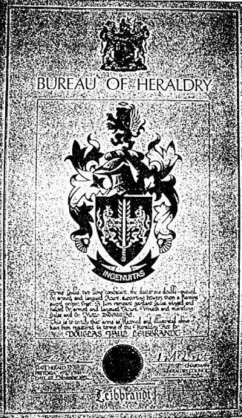
THE LEIBBRANDT COAT OF ARMS.

The above coat of arms was designed with all Leibbrandt's in mind.
The flaming sword in the center symbolizes the meaning of the name 'The People of the Burning Sword'. The lions are the Bavarian lions, note the left hand one has two tails. The lion above the helm is in honour of the Leibbrandt spelled Luitprand, a Bishop of Cremona(~ 920-972), the lion of Lombardy. To him we owe a history, and the origin of the name, because the King of Lombardy, Luitprand (713-744 A D) probably went into battle with 'a burning sword'. Read the next section on Page ii , the Leibbrandt's.

The motto ' Ingenuitas' is Latin for ingenuity. Most Leibbrandt's seem to have this quality in abundance.

Legally , the owner and his offspring can use the coat of arms. As the legal owner I have no objection to any true Leibbrandt using my coat of arms. A true Leibbrandt is one born with the surname Leibbrandt.

(Document made ~1990 in S.A.by Douglas Paul Leibbrandt, born 1927)
CONTENTS.
Page Number.
Unnumbered.
The Leibbrandt's Coat of Arms.
Foreword and Layout. i.
The Leibbrandt's . (History) ii - iii xiv
The German Leibbrandt's iva- vii
Leibbrandt's INDEX OF NAMES. viii-x
Distaff INDEX OF NAMES. XXV-XXXV
The South African families, grouped in families. 32...1-
Individual short histories, opposite page to the family. 2a- 32a
Appendix. A. People untraced and unplaced.
Distaff relation information. Al - A27
Appendix. B. Short Biographies.
Hendrik Carel Vos B1 - B2
John Ro~naine Addison B2 - B4
Douglas Paul (the author) B5 - B7
GRAPH. To assist identification
Age Gap v. Child Number. B8
Appendix.C. The Walstra- Leibbrandt family. C1
The Spies- Leibbrandt family. C2
Appendix. D. Photographs.
9.2258. Hendrik Carel VOS/SINCLAIR. Dl. 3
9.2254. Pieter Ulrich/DE VAAL. D2. 3 , 7
9.2255. Johannes (Baasie) /BRESLER. D3. 3.
10.22554. Christoffel Johannes D4. 8.
Daughters of Christoffel. D4a. 8.
10.2253. Johann Sebastiaan *1820 +1842 D5a. 3.
11.225544. John Romaine Addison/WILSON. D5. 9.
Children of John Romaine. D6a-D6 9.
11.241232. John Percival Muller I D7a 14.
TOWNSEND and children. D7. 14.
12.2412322. Douglas Herbert/PATTERSON D8a. 17.
and children.
12.2412326. Victor Muller Payne/DAVIES D9a. 17.
and children.
13.24123222. Douglas Paul/KRUGER D10a 17.
and family D10. 31.
11.241241 and 11.241244. Johann /Hendrik D11. 13.
10.22927. Charles Gert Jacobus D12. 4 , 6.
12.2291213. Sidney Robey. D13. 26.
10.2258.12.2. William Albert and D14a 18.
10.2258.12.4. Eileen Louise. D14. 18.
10.22587. Pieter Paul Willem Jacob D15a. 9 , 26
His wife Emily ZINN.
11.225873. St Clair Royden and his wife D15a. 32.
Myrtle Dorothy Florence McKAY.
12.2258731. Anthony Errol and his first D15. 32.
wife Myra DONALDSON.
Please read the foreword to assist your search.

