 | Early Settlers in Medina County | 


Reisinger/Keller Family

Submitted by Carol Reisinger Eskra
Email: CLEskra@webtv.net

My 4rd great grandparents are Johann Jacob Keller, born before July 1735 in Kleiningersheim, and Christina Leibbrand, born Sept. 21, 1738 in Kleiningersheim. They married Oct. 19, 1762. in Kleiningersheim.

My 3rd great grandparents are David Keller, born Jan. 19, 1777 in Kleiningersheim and Johanna Christina Spahlinger born July 10. 1779 in Grossingersheim. They married Sept. 12, 1797.

In 1833, my 3rd great grandparents David Keller and Johanna Christina Spahlinger and 5 children immigrated from Stuttgart Germany to Liverpool Ohio. Enroute to Liverpool Johanna Spahlinger died of cholera and is buried in Euclid Ohio. David Keller worked for a grain elevator in Cleveland. He was offered a 100 acre farm for $500.00 but preferred to move to Liverpool where he purchased property. In 1834 my 2nd great grandfather Jacob Reisinger followed the Keller family to America. In Stuttgart, Jacob learned the trade of shoemaker and was offered similar work in Cleveland. For three years of service he would receive his board, $200.00 and 30 acres of land northwest of Cleveland Public Square. However, he preffered the heavier soil at Liverpool over the sandy soil in Cleveland and declined the offer.

Jacob Reisinger and Elizabeth Keller were married Oct. 13, 1834 in a Lutheran church in Liverpool Ohio. The Rev. G.W. Emmanuel Metzger officiated. A log cabin was built on a 40 acre farm southwest of Liverpool where 5 of their 12 children were born. In 1848 the family moved to Columbia Township Ohio where a log house was built on a 63 acre farm. Jacob would farm during the summer and in the colder weather he worked as a shoemaker traveling around the country, staying at each home until he made shoes for the entire family.

Jacob and Elizabeth are buried at Myrtle Hill cemetery.

Thank You,

Carol Reisinger Eskra

Return to Index
REISINGER GENEALOGY
Descendants of Jacob and Elizabeth (Keller) Reisinger, of Liverpool (Valley City), Ohio
fourth edition 1997

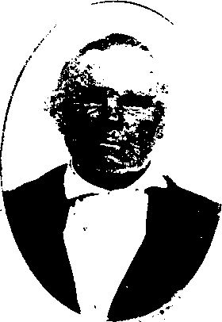
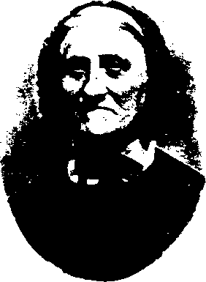

Elizabeth Keller
Jacob Reisinger

by
Thomas D. Ayres
3 Windham Dr.
Simsbury, CT 06070
860-651-8391

REISINGER
1. JACOB REISINGER was born Sept. 10, 1808, at Stuttgart, Germany, son of Peter Reisinger. He married Elizabeth Louisa Keller, daughter of David Keller and Johanna Christine (Spalinger) Keller, Oct. 12, 1834, at Liverpool (now Valley City), Ohio. She was born Oct. 10, 1810, at Gross Ingersheim, Germany. He died Apr. 12, 1885 and she died Mar. 30, 1886, both at Liverpool, Ohio. They were buried at Myrtle Hill Cemetery, Valley City, which is southwest of Cleveland.
Elizabeth lived in Stuttgart, Germany until 1833, when, with her parents, three brothers and one sister, she immigrated to America. Enroute to Cleveland, Ohio, her mother died and was buried at Euclid, Ohio. Her father worked at a grain elevator in Cleveland. He was offered a one hundred acre farm for $500 but preferred to move on to Liverpool (now Valley City), Ohio where he purchased property.
Jacob decided to follow Elizabeth to America. In 1834 he secured transportation on a sailing vessel, which was enroute one hundred and three days. Food supplies were extremely low when the ship was wrecked about three miles off the New Jersey coast. He managed to rescue his wooden chest which contained all of his possessions and swam to shore. The survivors were taken to a Swedish farm house where they were given their first American meal, consisting of corn meal mush and milk. Jacob went to Buffalo, NY via the Erie Canal on a barge pulled by two horses walking along the tow-path on the bank. In Stuttgart he had learned the trade of shoemaker and was offered similar work in Cleveland. For three years service he would receive his board, $200 and thirty acres of land northwest of Cleveland Public Square. However, he preferred the heavier soil at Liverpool over the sandy soil in Cleveland and declined the offer.
Jacob and Elizabeth were married in 1834 and they built a log cabin on a forty acre farm southwest of Liverpool. In 1848 they moved to Columbia Township Ohio where a log house was built (see Preface) on a sixty-three acre farm. He would farm during the summer. In the colder weather he worked as a shoemaker traveling around the country, staying at each home until he had made shoes for the entire family. Their children:
- John Gottleib Reisinger see #100.
- Joanna Christina Reisinger see #2.
- Jacob Reisinger see #200.
- Christian Reisinger see #300.
- Catherine Reisinger see #400.
- Martin Reisinger see #500.
- John J. Reisinger see #600.
- Elizabeth Reisinger see #3.
- Eliza Louise Reisinger see #700.

- William Reisinger see #800.
- Henry Reisinger see #900.
- Charles Reisinger see #4.

