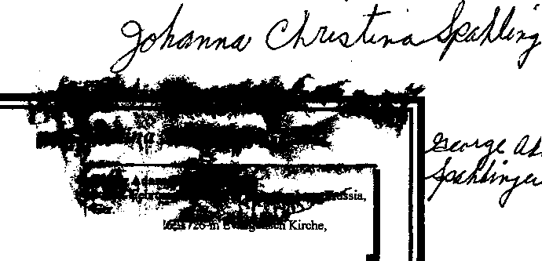
Ancestors of Johanna Christina SPAHLINGER₄
m: February; 26 1726 in Evangelisch Kirche
Grossingersheim, Neckarkreis, Wuerttemberg, Ger.

Mattheus Georg SPAHLINGER
b: Bef. September 12, 1739 in Wuerttemberg, Prussia, Ger.
m: May 03, 1763 in Evangelisch, Grossingersheim, Neckarkreis, Wuerttemberg, Ger.

Johanna Christina SPAHL INGER
b: July 10, 1779 in Gross Ingersheim, Ger.
m: September 12, 1797 in Klein Ingersheim,
Neckarkreis, Wuerttemberg, Ger.
d: 1832
Spouse: David KELLER
Maria Agnes GEIGER
b: Bef. May 13, 1705 in Wuerttemberg, Prussia, Ger.
Hans Michael GOECKLEN
b;Abt. 1720 in Germany m: Bef. 1744

Sophia Magdatena GOECKLEN
b: Bef. December 14, 1744 in Grossingersheim, Neckarkreis, Wuerttemberg, Crermany
Anna Maria
b: Abt. 1725 in Germany


Carol Eskra
10981 S.W. 81St..Ave. Ocala FL 34481

Tel. #352-854-4084

CLEskra@webtv.net

